GUI Programming or windows based

GUI stands for Graphical User Interface
GUI applications are windows based applications
Eg: calculator,paint,…
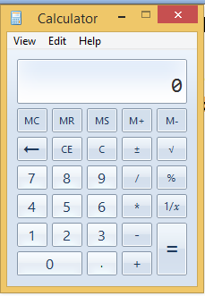
To develop windows based or gui application python provide n number of libraries.
- Tkinter
- Wxpython
- Kivy
- PyQT
Default library which comes with python software is tkinter
Tkinter package comes with python software, it is used for developing windows based or gui applications.

tkinter module comes with python software. It default GUI module which comes with python software.
Tkinter module provide graphical elements or objects, which are called widgets. Every widget is one type or class.
Eg: button, textbox, label, listbox,…
Tk class
Tk class/type is used to create top level window/window. This window hold/contain other widgets.

Example of creating window
import tkinter
def main():
window=tkinter.Tk()
window.geometry("300x300")
window.title("Window1")
window.config(bg="cyan")
window.mainloop()
main()

Button
The button is created using Button widget/class. all widgets are create within root window/window.
Button(window,properties/attributes)
text : display value/text which has to be displayed on button
bg: background color
fg: foreground color
font: set the fontname,size
image: the image which has to be displayed on button
command: the function which has to be executed when click on this button.
Example:
import tkinter
def main():
window=tkinter.Tk()
window.geometry("300x300")
window.title("Window1")
window.config(bg="cyan")
def fun1():
window.config(bg="yellow")
b1=tkinter.Button(window,text="Change Color",bg="pink",fg="blue",font=("Arial",14),command=fun1)
b1.place(x=100,y=100)
window.mainloop()
main()

every widget is having layout methods. Layout define how to organize widgets within window.
- Pack
- Grid
- Place
place() method is used to place the widget at given “x” and “y” positions.
widget.place(x=x-pos,y=y-pos)
Label Widget
Label widget is display item, where we can display value/data.
Syntax: Label(window,attributes)
text : text displayed inside the label
fg : font color
bg : background color of the label
font : font name,size
import tkinter
def main():
win=tkinter.Tk()
win.title("Welcome")
win.geometry("400x400")
win.config(bg="cyan")
l1=tkinter.Label(win,text="Banking Application",fg="Blue",bg="pink",font=("Arial",18))
l1.place(x=100,y=10)
win.mainloop()
main()

Entry widget
Entry widget is used to input data at runtime.
Syntax:
Entry(window,width,font,fg,bg,show)

import tkinter
def main():
window=tkinter.Tk()
window.title("Calculator")
window.geometry("300x300")
l1=tkinter.Label(window,text="Number",font=("Arial",14))
l2=tkinter.Label(window,text="Number",font=("Arial",14))
l3=tkinter.Label(window,text="Result",font=("Arial",14))
e1=tkinter.Entry(window,width=10,font=("Arial",14))
e2=tkinter.Entry(window,width=10,font=("Arial",14))
e3=tkinter.Entry(window,width=10,font=("Arial",14))
def add():
n1=int(e1.get())
n2=int(e2.get())
n3=n1+n2
e3.delete(0,tkinter.END)
e3.insert(0,str(n3))
def sub():
n1 = int(e1.get())
n2 = int(e2.get())
n3 = n1 - n2
e3.delete(0, tkinter.END)
e3.insert(0, str(n3))
def multiply():
n1 = int(e1.get())
n2 = int(e2.get())
n3 = n1 * n2
e3.delete(0, tkinter.END)
e3.insert(0, str(n3))
def div():
n1 = int(e1.get())
n2 = int(e2.get())
n3 = n1 / n2
e3.delete(0, tkinter.END)
e3.insert(0, str(n3))

b1=tkinter.Button(window,text="Add",font=("Arial",14),command=add)
b2=tkinter.Button(window, text="Sub", font=("Arial", 14),command=sub)
b3=tkinter.Button(window, text="Multiply", font=("Arial", 14),command=multiply)
b4=tkinter.Button(window, text="Division", font=("Arial", 14),command=div)
l1.grid(row=0,column=0)
l2.grid(row=1,column=0)
l3.grid(row=2,column=0)
e1.grid(row=0,column=1)
e2.grid(row=1,column=1)
e3.grid(row=2,column=1)
b1.grid(row=3,column=0)
b2.grid(row=3,column=1)
b3.grid(row=4,column=0)
b4.grid(row=4,column=1)

window.mainloop()
main()

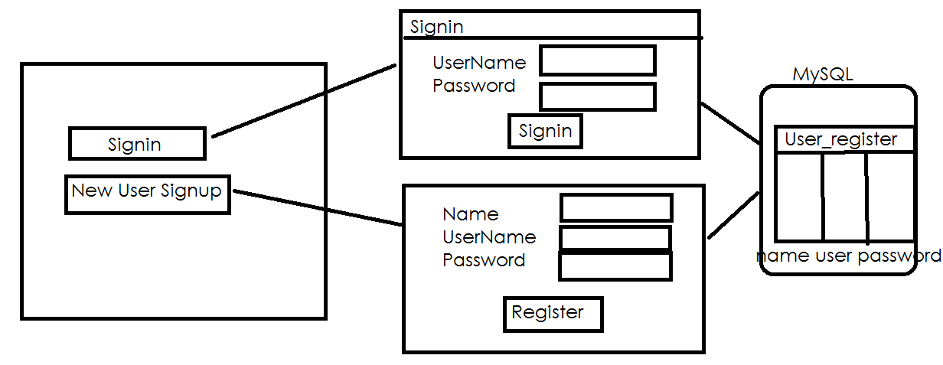

Create the following table in database
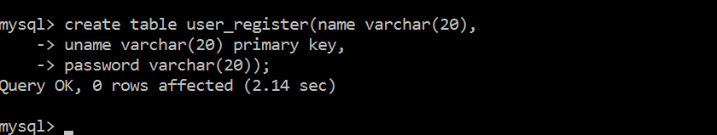

import tkinter
import tkinter.messagebox
import mysql.connector
cn=mysql.connector.connect(database="nitdb",user="root",password="root")
def main():
window=tkinter.Tk()
window.title("XYZ Application")
window.geometry("400x300")
def signup_window():
singnupw=tkinter.Tk()
singnupw.title("New User Signup")
singnupw.geometry("300x200")
l1=tkinter.Label(singnupw,text="Name",font=("Arial",14))
l2=tkinter.Label(singnupw,text="UserName",font=("Arial",14))
l3=tkinter.Label(singnupw,text="Password",font=("Arial",14))
e1=tkinter.Entry(singnupw,width=10,font=("Arial",14))
e2=tkinter.Entry(singnupw,width=10,font=("Arial",14))
e3=tkinter.Entry(singnupw,width=10,font=("Arial",14),show="*")
def signup():
c=cn.cursor()
c.execute("insert into user_register values (%s,%s,%s)",params=(e1.get(),e2.get(),e3.get()))
if c.rowcount>0:
tkinter.messagebox.showinfo("Registration","User Registered")
cn.commit()
b1=tkinter.Button(singnupw,text="Signup",font=("Arial",14),command=signup)
l1.grid(row=0,column=0)
l2.grid(row=1,column=0)
l3.grid(row=2,column=0)
e1.grid(row=0,column=1)
e2.grid(row=1,column=1)
e3.grid(row=2,column=1)
b1.grid(row=3,column=0)
singnupw.mainloop()
def signin_window():
signinw=tkinter.Tk()
signinw.title("Signin")
signinw.geometry("300x300")
l1=tkinter.Label(signinw,text="UserName",font=("Arial",14))
l2=tkinter.Label(signinw,text="Password",font=("Arial",14))
e1=tkinter.Entry(signinw,width=10,font=("Arial",14))
e2=tkinter.Entry(signinw,width=10,font=("Arial",14),show="*")
def signin():
c=cn.cursor()
c.execute("select * from user_register where uname=%s and password=%s",params=(e1.get(),e2.get()))
row=c.fetchone()
if row!=None:
tkinter.messagebox.showinfo("weclome","Welcome To applications")
else:
tkinter.messagebox.showinfo("Info","Invalid username or password")
b1=tkinter.Button(signinw,text="Signin",font=("Arial"),command=signin)
l1.grid(row=0,column=0)
l2.grid(row=1,column=0)
e1.grid(row=0,column=1)
e2.grid(row=1,column=1)
b1.grid(row=2,column=0)
signinw.mainloop()
b1=tkinter.Button(window,text="Signin",width=20,font=("Arial",16),fg="blue",command=signin_window)
b2=tkinter.Button(window,text="Signup",width=20,font=("Arial",16),fg="blue",command=signup_window)
b1.place(x=100,y=100)
b2.place(x=100,y=150)
window.mainloop()
main()

